**Artefact Designs - Group**

**Low Fidelity designs**

The low fidelity designs for this project are rough ideas of our vision as a group, of how we expect the project to look like. This includes a storyboard, where we set the scene and the narrative of the gameplay. This involves the ship flying over, the scientist landing and a proposed tutorial session, so the player can come to grips with the controls before taking part in the official levels of the game.

These designs also feature multiple pieces of art from the artists, giving conceptual ideas for how the art style will look and the designs of certain aspects. Such as the level design, where it will be set in the jungle. These are concepts that are great tools to use to visualise our game before the creation has begun, it heavily helps in preparing the official assets with reference images rather than starting inside of the Unity editor.

The first image displays all the rough ideas for the characters, enemies and pickups in the game. This is essentially to set a tone and art style for the game. With minimalistic features but easily identifiable assets by colour, shape and size.

**High Fidelity designs**

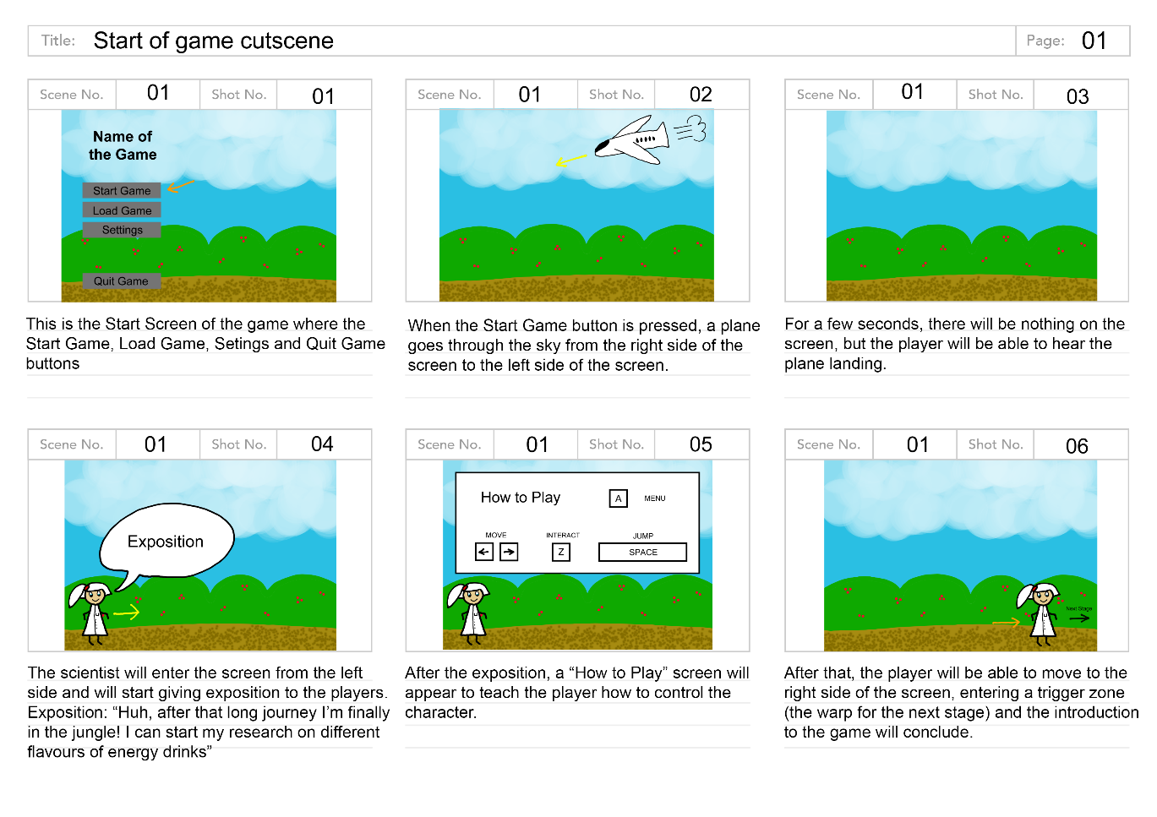High fidelity designs are the characters of the game so far, these were created first in the high-quality prototype because of efficiency. This allows a sprite with working animations to be passed onto the programmer to create movements for the character. This makes a very suitable scenario to visualise what the project is aimed to look like.

The level system for this game includes two levels which contain three stages. An idea for this system would be to have different locations in the jungle. One of the stages could be above the jungle’s trees or in the clouds.

Low fidelity designs have been created to visualize these ideas. Including these different locations will allow for different scenarios. Thus, giving the player the opportunity to use the energy drinks and the power ups to move onto the next stage.

In this example stage, the player would be able to consume two of the six types of energy drinks; Grape (jump higher) and Apple (Invisibility). These drinks correspond with this level the most because the whole idea would be to jump onto clouds and not fall and avoiding enemies in the air.

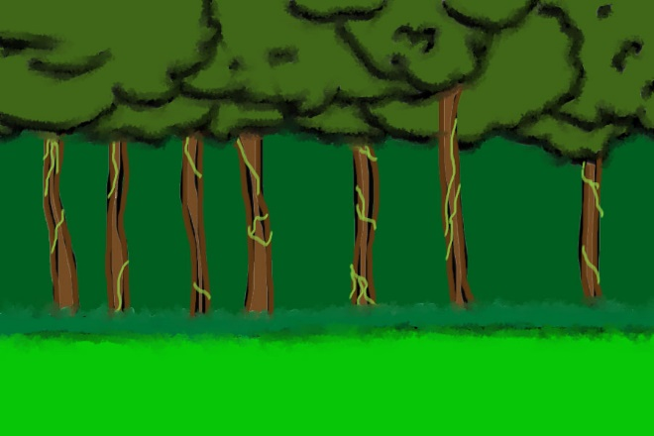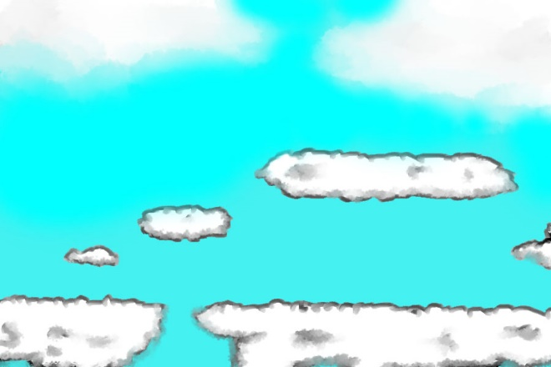Another location amongst the stages would be the jungle floor. In this stage, the player would be able to consume two of the six types of energy drinks; Blueberry (throw rocks) and Banana (Super strength). These energy drinks would be the most appropriate for this this stage, as this level will contain a lot of trying to defeat enemies and possibly moving heavy objects. The only way to get through these obstacles will be to consume the drinks.

The final location choice for the game would be underground or in some sort of cave system. The main idea of the different locations is trying to create various scenarios all within the jungle but also having an obvious change in scenery. This will increase the players interest, as it’s not all in the same location.

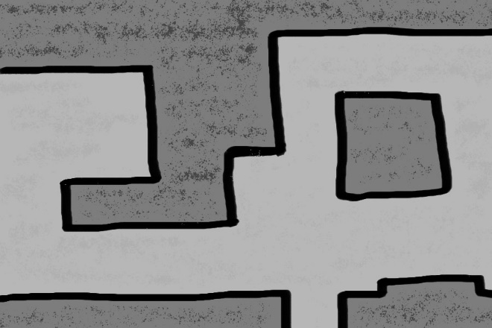In this stage, the player would be able to consume two of the six types of energy drinks; Carrots (Seeing in the dark) and Kiwi (Minimize). These ingredients are very appropriate to this stage because there is the possibility that the caves might be too dark, and the player will have to find the Carrot to be able to see. Or there may be a small hole in which the player can only get through, if they find the Kiwi.





